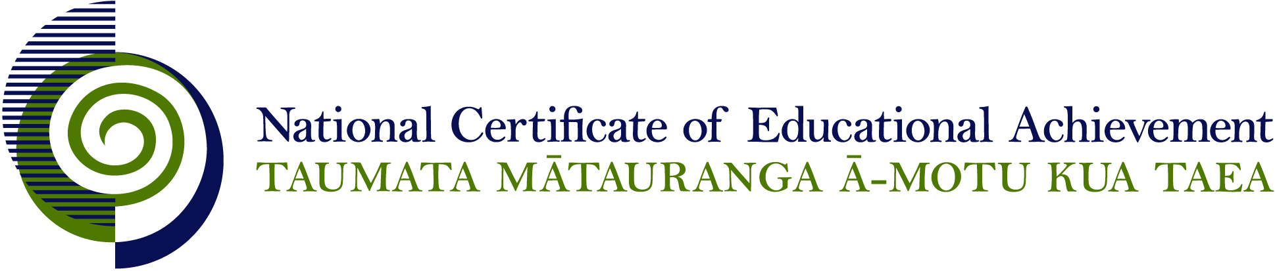

NCEA Level 2 Visual Arts

Conditions of Assessment

General Information

Subject Reference | Visual Arts
Domain | Practical Art
Level | 2

Conditions of Assessment

These Conditions provide guidelines for assessment against internally assessed Achievement Standards. Guidance is provided on:
- specific requirements for all assessments against this Standard
- appropriate ways of, and conditions for, gathering evidence
- ensuring that evidence is authentic.

Assessors must be familiar with guidance on assessment practice in learning centres, including enforcing timeframes and deadlines. The NZQA website offers resources that would be useful to read in conjunction with these Conditions of Assessment.

The learning centre’s Assessment Policy and Conditions of Assessment must be consistent with NZQA’s Assessment Rules for Schools with Consent to Assess. This link includes guidance for managing internal moderation and the collection of evidence.

Gathering Evidence

Internal assessment provides considerable flexibility in the collection of evidence. Evidence can be collected in different ways to suit a range of teaching and learning styles, and a range of contexts of teaching and learning. Care needs to be taken to allow students opportunities to present their best evidence against the Standard(s) that are free from unnecessary constraints.

It is recommended that the design of assessment reflects and reinforces the ways students have been learning. Collection of evidence for the internally assessed Standards could include, but is not restricted to, an extended task, an investigation, digital evidence (such as recorded interviews, blogs, photographs, or film), or a portfolio of evidence.

Effective assessment should suit the nature of the learning being assessed, provide opportunities to meet the diverse needs of all students, and be valid and fair.

Ensuring Authenticity of Evidence

Authenticity of student evidence needs to be assured regardless of the method of collecting evidence. This must be in line with the learning centre’s policy and NZQA’s Assessment Rules for Schools with Consent to Assess.

Ensure that the student’s evidence is individually identifiable and represents the student’s own work. The evidence must be an accurate reflection of what the student independently knows and can do, according to the Standard being assessed. This includes evidence submitted as part of a group assessment, evidence produced outside of class time or without assessor supervision, and evidence produced with any use of generative artificial intelligence tools (GenAI). GenAI use should be carefully considered in the context of the Standard being assessed and its Conditions of Assessment, discussed with students before the assessment, and its use must be acknowledged. For example, an investigation carried out over several sessions could include:
- teacher guidance on the nature and extent of acceptable GenAI use, if any
- assessor observations and conversations
- meeting with the student at set milestones or checkpoints
- the student’s record of progress, such as photographic entries or any GenAI prompts used.

Specific Information for Individual Internal Achievement Standards

Achievement Standard Number | 91305 Design Visual Arts 2.1  91306 Painting Visual Arts 2.1  91307 Photography Visual Arts 2.1  91308 Printmaking Visual Arts 2.1  91309 Sculpture Visual Arts 2.1
Title | Demonstrate an understanding of methods and ideas from established practice appropriate to design/painting/ photography/printmaking/sculpture
Number of Credits | 4
Version | 2

Evidence may be presented by the student in a range of forms, including:
- written notes or paragraphs
- annotated drawings, photocopies and diagrams
- oral presentations
- data display presentations
- audio recordings
- visual recordings.

Students must use their own words to present evidence for this standard.
It is recommended that research sources are acknowledged.

Achievement Standard Number | 91310 Design Visual Arts 2.2  91311 Painting Visual Arts 2.2  91312 Photography Visual Arts 2.2  91313 Printmaking Visual Arts 2.2  91314 Sculpture Visual Arts 2.2
Title | Use drawing methods to apply knowledge of conventions appropriate to design/painting/photography/printmaking/sculpture
Number of Credits | 4
Version | 2

Evidence should demonstrate an awareness of the characteristics and constraints of the field (design/painting/photography/printmaking/sculpture).

Ways in which evidence may be submitted include:
- original artwork: drawing, sketches, painting, collage, colour studies, media experiments, montage, contact sheets, photograms, photographs, mock ups, prints
- digital still image: reproductions of originals should include details of size and media
- digital moving image
- 2, 3 or 4 dimensional: models, maquettes, sculpture, installation, performance, time based work
- written annotations.

Achievement Standard Number | 91315 Design Visual Arts 2.3  91316 Painting Visual Arts 2.3  91317 Photography Visual Arts 2.3  91318 Printmaking Visual Arts 2.3  91319 Sculpture Visual Arts 2.3
Title | Develop ideas in a related series of drawings appropriate to established design/painting/photography/printmaking/sculpture practice
Number of Credits | 4
Version | 2

When referring to established practice a range of examples of artworks should be referenced with regard to the genre, style, convention or way of working. Evidence should demonstrate an awareness of the characteristics and constraints of the field (design/painting/photography/printmaking/sculpture).

Ways in which evidence may be submitted include:
- original artwork: drawing, sketches, painting, collage, colour studies, media experiments, montage, contact sheets, photograms, photographs, mock ups, prints
- digital still image: reproductions of originals should include details of size and media
- digital moving image
- 2, 3 or 4 dimensional: models, maquettes, sculpture, installation, performance, time based work
- written annotations.

Achievement Standard Number | 91325 Visual Arts 2.5
Title | Produce a resolved work that demonstrates control of skills appropriate to cultural conventions
Number of Credits | 4
Version | 2

Learning contexts for this standard may include:
- individual projects
- collaborative projects
- site specific work
- installation
- intermedia approaches
- marae based practices
- time based practices.

Where collaborative or group projects are undertaken strategies need to be developed to facilitate the assessment of individual learners. This may include:
- designated roles and/or parts within a group project
- a tracking system to monitor individual contributions, e.g. a log of teacher observation
- teacher observation and teacher/student conferencing can be used to verify individual student’s contribution to the collaborative process
- production diary noting individual contributions to the project
- peer assessment, used in conjunction with teacher input
- limiting group numbers, depending on the context.

Ways in which evidence may be submitted include:
- original artwork
- digital still image: reproductions of originals should include details of size and media
- digital moving image
- 2, 3 or 4 dimensional
- audio-visual
- research and preparatory evidence (for the purposes of making informed judgements about the resolved work)
- artist statement (for the purposes of making informed judgements about the resolved work).

